Assignment 1
Course Code - CAP454
Course Teacher – Navpreet Kaur
Name – Aniket Kumar
Registration Number - 12108348
Section - D2112
Roll Number – RD2112B81
Attempted Set - B
Date of Submission – 30-09-2021
Que1. Create a video which demonstrates the implementation of hard link and soft link and upload it on google drive. Write the steps for the same in a file and upload file on LPUUMS. Also include the google drive link in this file.

- A link is an entry in your file system which connects a file name to the actual bytes of data on the disk. More than one file name can "link" to the same data.
- The links are basically pointers that are associated to the files and directories.
- The two kinds of links are:
  - Hard link – It is the direct link to the data on the disk.
  - Soft link – It is also known as symbolic link, which is an abstract link to the data.
- The major difference between a hard link and soft link is that hard link is the direct reference to the file whereas soft link is the reference by name which means it points to a file by file name.
- This is the reason, on deleting a hard linked file, the other file is not deleted, but in case of soft link, both files are deleted.
- Following is the implementation of hard link and soft link:

Implementation of hard link
- To create a hard link, we use link command.
- Syntax: link <original_file> <new_file_name>
- Here, this command will automatically create a linked file with the given name.
- Example: link linux.txt hard_linux.txt
- When we delete the original file, the hard linked file is not deleted.
- It can only be used on files, not on directories.

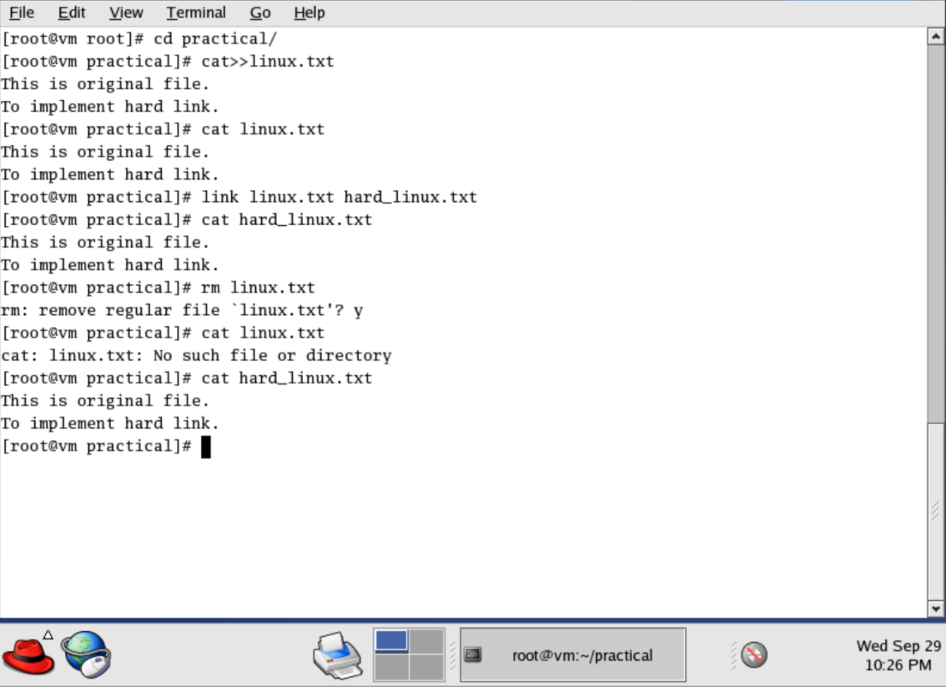

Implementation of soft link
- To create a hard link, we use ln -s command.
- Syntax: ln -s <original_file> <new_file_name>
- Here, this command will automatically create a linked file with the given name.
- Example: ln -s linux.txt hard_linux.txt
- when we delete original file, the soft linked file also gets deleted.
- We can use it on both files and directories.

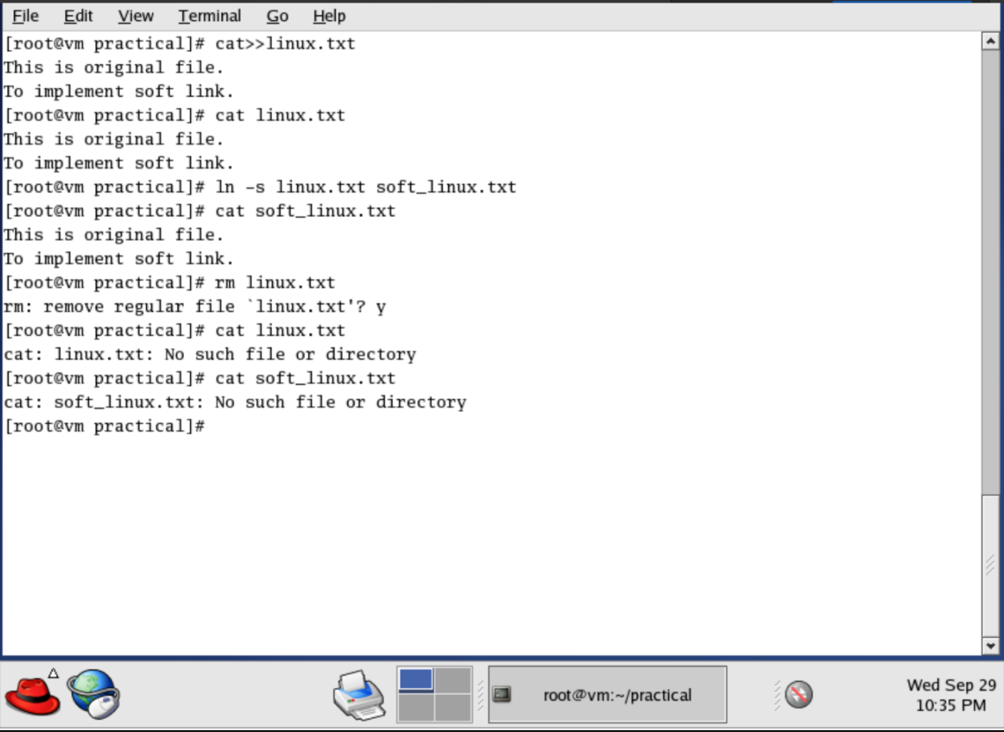
Link of the video:
https://drive.google.com/file/d/1e29dbJietYlRIYIWb-qWDHJ7TT2l4OVx/view?usp=sharing

Que2. Locate package nfs and vsftpd. Perform all operations of rpm on these packages. Write the steps and attach screenshots to the same file where you wrote steps of Que1.

Locating and performing operations on nfs rpm package.
- nfs package can be found in disc 1 of the iso file.

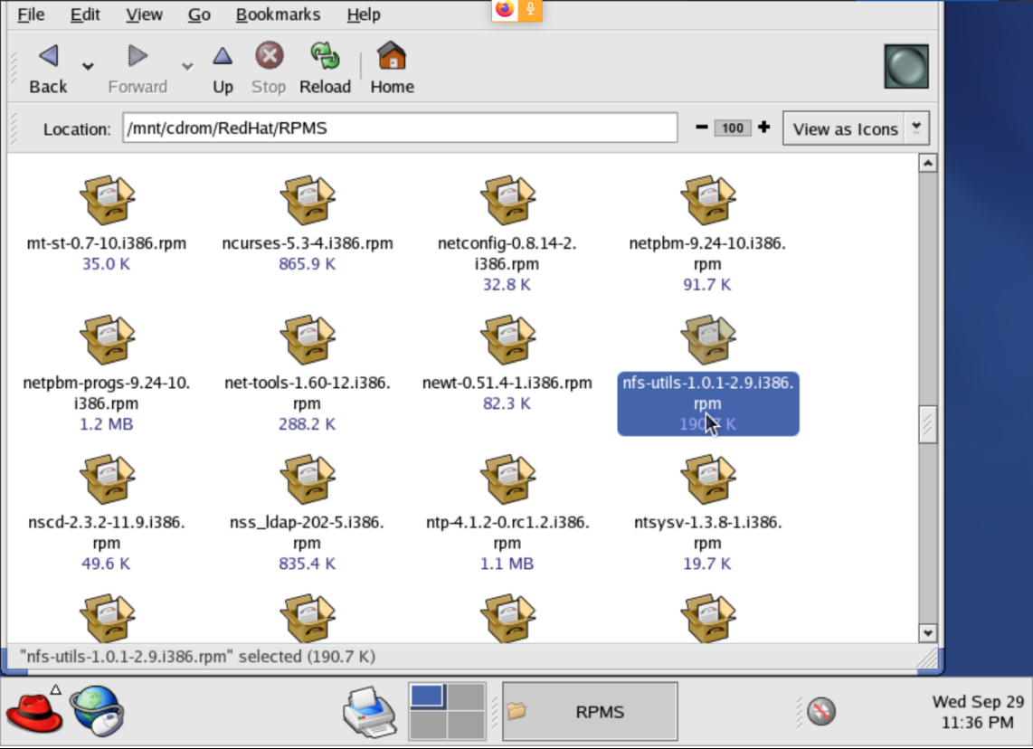
- We can connect/attach the disc in the system and then navigate to the /mnt/cdrom/RedHat/RPMS.
- Here, we can find the nfs rpm package, and we note the path of it.
- Installing:
  - To install the package, we use rpm -ivh command.
  - Syntax – rpm -ivh <path/complete_package_name.rpm>
  - Here, i is for installation, v for verbose and and h for hash.
  - Here: rpm -ivh /mnt/cdrom/RedHat/RPMS/nfsutils-1.0.1-2.9.i386.rpm
- Upgrading:
  - To upgrade a package, we use rpm -Uvh command.
  - Syntax – rpm -Uvh <path/complete_package_name.rpm>
  - Here: rpm -Uvh /mnt/cdrom/RedHat/RPMS/nfsutils-1.0.1-2.9.i386.rpm
- Querying:
  - To query a package, we use rpm -q command.
  - Syntax – rpm -q <package_name.>
  - Here: rpm q nfs-utils
  - It will output with the version number.
- Verifying:
  - To verify a package, we use rpm -V command.
  - Syntax – rpm -V <package_name>
  - Here: rpm -V nfs-utils
  - If it’s successfully run, there will be no output.
- Uninstalling:
  - To uninstall a package, we use rpm -e command.
  - Syntax – rpm -e <package_name>
  - Here: rpm -e nfs-utils

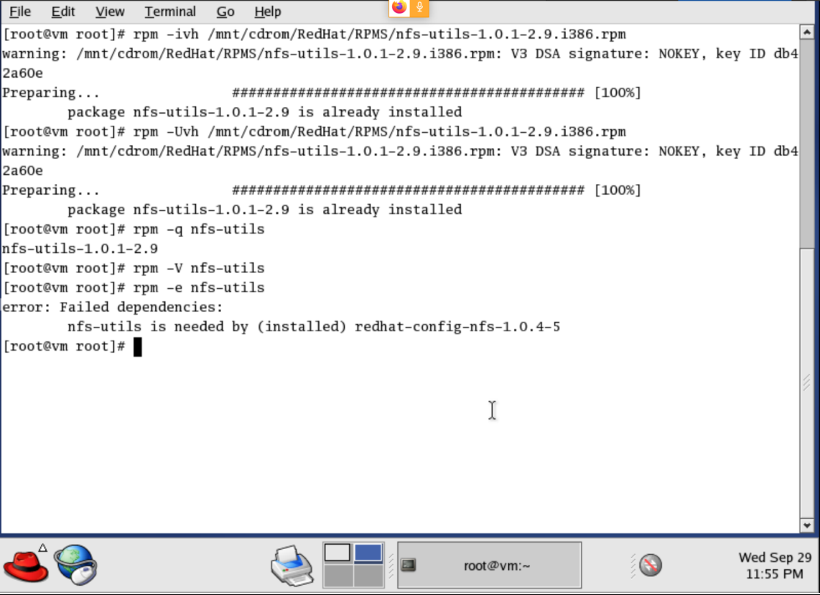
Locating and performing operations on vsftpd rpm package.
- vsftpd package can be found in disc 3 of the iso file.

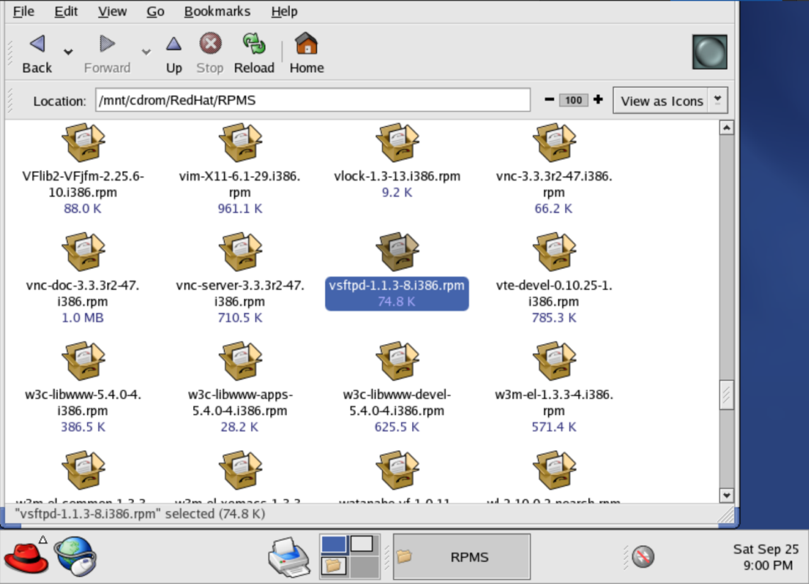

- We can connect/attach the disc in the system and then navigate to the /mnt/cdrom/RedHat/RPMS.
- Here, we can find the nfs rpm package, and we note the path of it.
- Installing:
  - To install the package, we use rpm -ivh command.
  - Syntax – rpm -ivh <path/complete_package_name.rpm>
  - Here, i is for installation, v for verbose and and h for hash.
  - Here: rpm -ivh /mnt/cdrom/RedHat/RPMS/vsftpd-1.1.3-8.i386.rpm
- Upgrading:
  - To upgrade a package, we use rpm -Uvh command.
  - Syntax – rpm -Uvh <path/complete_package_name.rpm>
  - Here: rpm -Uvh /mnt/cdrom/RedHat/RPMS/vsftpd-1.1.3-8.i386.rpm
- Querying:
  - To query a package, we use rpm -q command.
  - Syntax – rpm -q <package_name.>
  - Here: rpm q vsftpd
  - It will output with the version number.
- Verifying:
  - To verify a package, we use rpm -V command.
  - Syntax – rpm -V <package_name>
  - Here: rpm -V vsftpd
  - If it’s successfully run, there will be no output.
- Uninstalling:
  - To uninstall a package, we use rpm -e command.
  - Syntax – rpm -e <package_name>
  - Here: rpm -e vsftpd
  - If it’s successfully run, there will be no output.

